
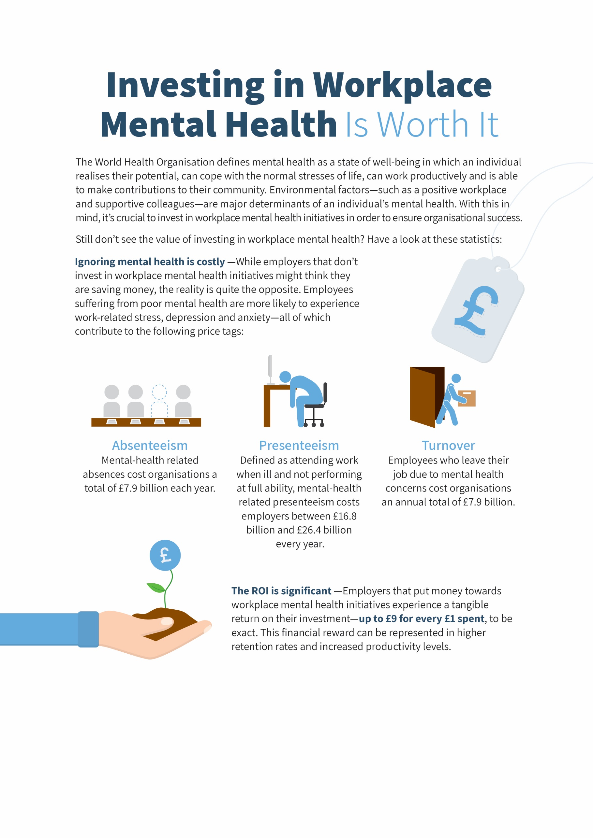
Put simply, your organisation can’t afford to ignore employees’ mental health. Contact Sutcliffe & Co. Insurance Brokers today for more guidance and insurance solutions.
© 2019 Zywave, Inc. All rights reserved.

